**CHAPTER III**

**METHODOLOGY**

**Research Approach**

This study adopts the Modified Waterfall model to guide the design, development, and testing of **KITCHENPAL: A Smart Cooking App for Simplified Meal Preparation**.

The Waterfall methodology is a traditional and structured approach to software development, characterized by a linear and sequential flow through its phases: Requirements, Design, Implementation, Testing, Deployment, and Maintenance. However, the Modified Waterfall model introduces flexibility, allowing for iterative refinements and adjustments between phases based on feedback and emerging requirements.

This approach ensures that the development process is both systematic and adaptable, allowing for thorough planning and quality control at each stage while accommodating the possibility of revisiting earlier phases as necessary. The Modified Waterfall model is well-suited to the KITCHENPAL project as it minimizes ambiguity, supports clear documentation, and reduces the risk of scope creep, leading to the development of a robust and functional cooking application.

**System Development Methodology**

To guide the development of KITCHENPAL, a structured and methodical approach was essential. The Modified Waterfall Model was selected to provide a sequential yet flexible development process. This model ensures discipline across each phase while allowing limited feedback and iteration. The following figure illustrates how the Modified Waterfall Model was applied throughout the project's lifecycle.

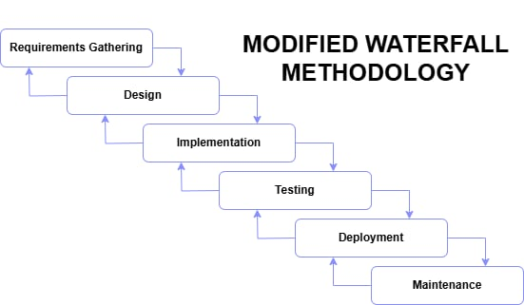

**Figure 1 Modified Waterfall Methodology**

**Figure 1:** As stated in the Research Approach section, this study adopts the Modified Waterfall Model as its system development methodology. This model was chosen due to the clearly defined requirements and the predominantly linear nature of the project, while still allowing limited feedback between phases.

The stages of the Waterfall model applied in this study are:

**1. Requirements Gathering**

In this phase the researcher conducted Informal interviews and surveys with home cooks and novice cook to gather requirements. Users expressed the need for an app that suggests recipes based on available ingredients without requiring them to manage a complete pantry inventory.

**2. System Design**

In this phase, sample prototypes have been developed using Figma based on the gathered requirements. The design focuses on creating a clean, simple, and user-friendly interface suitable for both home cooks and novice users. The current prototypes serve as the basis for further refinement and validation. The design also considers future adaptability to new tools and technologies that may improve usability and performance.

**3. Implementation**

The application will be developed using React Native for the frontend to ensure cross-platform compatibility. The backend will be designed to handle ingredient inputs, generate AI-driven recipe suggestions, and manage user profiles and data. Although the initial version will include only a single administrator account, the system architecture will support multiple administrators. This role-based structure is defined during the design phase to allow for future scalability. The development process follows a modified Waterfall model, allowing limited iterations and feedback incorporation between phases while maintaining a structured, phase-based approach.

**4. Testing**

Comprehensive testing will be conducted after development, including unit testing, integration testing, and usability testing. Feedback will be collected from test users to identify bugs and verify that system functions align with the defined requirements.

**5. Deployment**

After successful testing, the final version of the application will be deployed to Google Play Store. The initial deployment will include a beta release to gather user feedback before a full public launch.

**6. Maintenance**

Although the traditional Waterfall model does not emphasize iterative updates, the modified Waterfall approach allows for limited feedback integration between phases. User feedback from the deployed version will be systematically recorded and analyzed. Necessary fixes, updates, or improvements will be implemented in future development cycles, following the structured process of the modified Waterfall model.

**System Requirements Specification**

This section outlines the different requirements needed for the development and operation of the KITCHENPAL mobile application. These requirements help guide the system design, development, and deployment.

**Functional Requirements**

These are the core functions that the system must perform:

* User Account Management: The system shall allow users to create, log in, and manage their profiles.
* Available Ingredients Prompt: The system shall provide an interface for users to input ingredients they have available.
* AI-Powered Recipe Generator: The system shall utilize artificial intelligence to process the input ingredients and generate a list of relevant recipe suggestions.
* Recipe Display: The system shall display detailed recipe information, including ingredients, step-by-step cooking instructions.
* Step-by-Step Cooking Instructions: The system shall present cooking instructions in a clear, sequential format that is easy for users to follow.
* Save Recipe: The system shall allow users to save newly created or AI-generated recipes to their personal collection for later use or modification and allow users to rename it.
* Save Favorite Recipes: The system shall allow users to save recipes to a personalized list of favorites for easy access.
* User Profile Editing: The system shall enable users to modify their profile information and preferences.
* The application shall include a built-in admin account accessible through the same app. The sole administrator can log in to manage user accounts, update or cancel subscriptions, ban or unban users, and generate reports such as user statistics, subscription details, and usage metrics.

**Non-Functional Requirements**

The Non-Functional Requirements for the KITCHENPAL application are outlined in this section. Unlike functional requirements, which specify what the system must do, these requirements describe the system's quality attributes. This includes aspects like performance, usability, reliability, security, and maintainability. These factors are crucial for ensuring a satisfactory user experience and the application's effectiveness.

**Categories:**

The following categories outline the key non-functional aspects of the KITCHENPAL application:

1. Performance: Describes the system's speed, responsiveness, efficiency, and ability to handle load.

2. Usability: Defines the ease of use and user learnability with the system.

3. Reliability: Specifies the system's availability, stability, and ability to recover from failures.

4. Security: Addresses the protection of data and the system from unauthorized access.

5. Maintainability: Relates to the ease with which the system can be modified, tested, and evolved.

**Detailed Non-Functional Requirements**

**1. Performance**

* Speed:
  + The app is expected to load within approximately 2 seconds under normal network conditions.
  + Recipe search results should be displayed within approximately 3 seconds, depending on input complexity and server response time.
* Responsiveness: The app should respond to user interactions (taps, swipes) with minimal delay.
* Efficiency: The app should minimize battery consumption and efficiently manage data usage.
* Scalability: The system should be able to handle a growing number of users and recipes without significant performance degradation.

**2. Usability**

* Ease of Use: The app should have an intuitive and user-friendly interface, and navigation should be clear and consistent.
* Learnability: Users should be able to easily learn how to use the app's features.

**3. Reliability**

* Availability: The app should be available to users with minimal downtime.
* Stability: The app should be stable and not prone to crashes or errors.

**4. Security**

* Data Protection: User data should be stored securely, and the app should protect against unauthorized access.
* Authentication: User authentication should be secure.
* Privacy: The app should comply with privacy regulations and protect user privacy.

**5. Maintainability**

* Modularity: The app should be designed in a modular way to facilitate future changes and updates.
* Testability: The app should be designed to be easily testable.
* Evolvability: The app should be designed to accommodate future enhancements and new features.

**Input Requirements**

**Output Requirements**

This section describes what the KitchenPal app will show or give to the user after they use it. These outputs include things like recipe suggestions, cooking instructions, and helpful messages. By clearly listing these outputs, we can make sure the app works the way users expect and gives them the information they need for easy meal preparation.

|  |  |
| --- | --- |
| Output Type | Description |
| Personalized recipe suggestions | Recipes generated based on the list of ingredients provided by the user. |
| Step-by-step cooking instructions | Detailed, sequential directions for preparing the selected recipes. |
| System feedback notifications | Messages confirming user actions such as account creation, login success, saving recipes, or settings changes. |
| Recipe quota notifications | Alerts informing users of remaining recipe search limits, particularly for free or subscription plans. |

**Table 2** Output Requirements

**Software Requirements**

These requirements were gathered and finalized prior to the system's design and implementation phases, following the Waterfall model.

These are the necessary software tools and platforms.

|  |  |
| --- | --- |
| Operating System | Windows 10 Home or Higher |
| Front End | React Native 0.79 |
| Backend | Firebase Android SDK (BoM version 32.7.2) |
| Database | Firebase Cloud Firestore (Firebase) |
| Design Tools | Figma 125.4.7 |
| AI | GPT-4omni |
| Mobile Operating System: | Android 12 or above |

**Table 3** Software Requirements

**Hardware Requirements**

These are the minimum hardware specifications required:

|  |  |
| --- | --- |
| Hardware Components | Requirement |
| Smartphone | Android 12, 1.8 GHz Octa-core processor, 4 GB RAM, 64 GB storage |
| Wi-fi or Mobile Data | 3G/4G connectivity, minimum 5 mbps speed |
| Touchscreen | Capacitive touchscreen, 5 inch or larger |
| Laptop or Desktop | Intel Core I5, 8GB RAM, 256 GB SSD, 15-inch screen FullHD |
| Keyboard | Standard USB or Bluetooth |
| Mouse | Basic USB or Bluetooth |
| Monitor | 15-inch or larger Full HD display |

**Table 4** Hardware Requirements

**System Analysis**

The purpose of this application is to help users find recipes based on the ingredients they already have. Many people find it hard to decide what to cook, especially when they only have a few ingredients at home. This app, KITCHENPAL, solves that problem by suggesting recipes that match what the user has in their kitchen.

The system will allow users to create an account, add ingredients they have, and receive recipes they can cook with those items. Users can also save their favorite recipes, search for other meal ideas, and view step-by-step cooking instructions.

To make sure the app is helpful and easy to use, the system is designed with the user in mind. It includes features like:

* A simple interface for adding ingredients.
* Recipe suggestions that update based on what ingredients are added.
* Easy-to-follow instructions for cooking.
* An account system to save data and personalize the experience.

This analysis shows that the system focuses on solving a real-world problem (deciding what to cook), and provides a practical solution through a smart and user-friendly mobile app.

**Data Dictionary**

The data dictionary explains the important data used in the system, including the names of the tables, fields, data types, and short descriptions. It helps to understand how information is stored and organized in the app.

**1. Users Table**

Stores essential information about each registered user, including authentication and role data.

|  |  |  |
| --- | --- | --- |
| **Column Name** | **Data Type** | **Description** |
| user_id | INT IDENTITY | Primary key. Unique identifier for each user. |
| username | VARCHAR(100) | Unique username used for login. |
| password_hash | NVARCHAR(MAX) | Encrypted password. |
| full_name | VARCHAR(100) | Full name of the user. |
| is_admin | BIT | Indicates if the user is an admin (1) or not (0). |
| created_at | DATETIME | Timestamp of account creation. |

**Table 5** Users Table

**2. Ingredients Table**

Contains the master list of available ingredients recognized by the application.

|  |  |  |
| --- | --- | --- |
| Column Name | Data Type | Description |
| ingredient_id | INT IDENTITY | Primary key. Unique identifier for each ingredient. |
| name | VARCHAR(100) | Name of the ingredient. Must be unique. |

**3. User_Ingredients Table**

Tracks the ingredients added by each user, including the quantity and timestamp.

|  |  |  |
| --- | --- | --- |
| Column Name | Data Type | Description |
| user_ingredient_id | INT IDENTITY | Primary key. |
| user_id | INT | Foreign key referencing Users(user_id). |
| ingredient_id | INT | Foreign key referencing Ingredients(ingredient_id). |
| quantity | VARCHAR(50) | Quantity or unit as entered by the user. |
| created_at | DATETIME | Timestamp when the ingredient was added. |

**Table 6** Ingredients Table

**4. Recipes Table**

Holds information about all recipes, both user-created and AI-generated.

|  |  |  |
| --- | --- | --- |
| Column Name | Data Type | Description |
| recipe_id | INT IDENTITY | Primary key. |
| title | VARCHAR(255) | Title of the recipe. |
| description | TEXT | Optional description of the recipe. |
| created_by | INT | Foreign key referencing Users(user_id). Nullable. |
| is_ai_generated | BIT | Indicates whether the recipe is AI-generated. |
| created_at | DATETIME | Timestamp of recipe creation. |

**Table 7** Recipes Table

**5. Recipe_Ingredients Table**

Defines the many-to-many relationship between recipes and ingredients, with specified amounts.

|  |  |  |
| --- | --- | --- |
| Column Name | Data Type | Description |
| recipe_ingredient_id | INT IDENTITY | Primary key. |
| recipe_id | INT | Foreign key referencing Recipes(recipe_id). |
| ingredient_id | INT | Foreign key referencing Ingredients(ingredient_id). |
| quantity | VARCHAR(50) | Required amount for the recipe. |

**Table 8** Recipe_Ingredients Table

**6. Recipe_Steps Table**

Stores the ordered instructions for preparing each recipe.

|  |  |  |
| --- | --- | --- |
| Column Name | Data Type | Description |
| step_id | INT IDENTITY | Primary key. |
| recipe_id | INT | Foreign key referencing Recipes(recipe_id). |
| step_number | INT | The order of the step in the recipe. |
| instruction | TEXT | Description of the step. |

**Table 9** Recipe_Steps Table

**7. Saved_Recipes Table**

Allows users to save custom-named copies of existing recipes.

|  |  |  |
| --- | --- | --- |
| Column Name | Data Type | Description |
| saved_recipe_id | INT IDENTITY | Primary key. |
| user_id | INT | Foreign key referencing Users(user_id). |
| original_recipe_id | INT | Foreign key referencing Recipes(recipe_id). |
| title | VARCHAR(255) | User-defined title for the saved recipe. |
| description | TEXT | Optional notes or modifications. |
| created_at | DATETIME | Timestamp of when the recipe was saved. |

**Table 10** Saved_Recipes Table

**8. Favorite_Recipes Table**

Tracks which recipes each user has marked as favorites.

|  |  |  |
| --- | --- | --- |
| Column Name | Data Type | Description |
| favorite_id | INT IDENTITY | Primary key. |
| user_id | INT | Foreign key referencing Users(user_id). |
| recipe_id | INT | Foreign key referencing Recipes(recipe_id). |
| created_at | DATETIME | Timestamp when the recipe was favorited. |

**Table 11** Favorite_Recipes Table

**9. Subscriptions Table**

Records subscription details for each user.

|  |  |  |
| --- | --- | --- |
| Column Name | Data Type | Description |
| subscription_id | INT IDENTITY | Primary key. |
| user_id | INT | Foreign key referencing Users(user_id). |
| plan_name | VARCHAR(50) | Subscription plan type (Free, Premium, etc.). |
| start_date | DATE | Date the subscription started. |
| end_date | DATE | Subscription end or renewal date. |
| status | VARCHAR(20) | Current status of the subscription. |

**Table 12** Subscriptions Table

**10. Recipe_Search_Logs Table**

Logs recipe search activities to monitor usage and enforce limits.

|  |  |  |
| --- | --- | --- |
| Column Name | Data Type | Description |
| search_id | INT IDENTITY | Primary key. |
| user_id | INT | Foreign key referencing Users(user_id). |
| search_time | DATETIME | Timestamp of when the search was made. |

**Table 13** Recipe_Search_Logs Table

**11. Admin_Actions Table**

Maintains an audit log of administrative activities.

|  |  |  |
| --- | --- | --- |
| Column Name | Data Type | Description |
| action_id | INT IDENTITY | Primary key. |
| admin_id | INT | Foreign key referencing Users(user_id). The admin performing the action. |
| target_user_id | INT | Foreign key referencing Users(user_id). The affected user. |
| action_type | VARCHAR(50) | Type of action (e.g., ban, unban, reset_password). |
| action_details | TEXT | Additional information or explanation. |
| timestamp | DATETIME | Time the action occurred. |

**Table 14** Admin_Actions Table

**12. Help_Requests Table**

Stores messages or support requests submitted by users via the Help and Support feature.

|  |  |  |
| --- | --- | --- |
| **Column Name** | **Data Type** | **Description** |
| request_id | INT IDENTITY | Primary key. Unique ID for each help request. |
| user_id | INT | FK → Users.user_id. The user who submitted the request. (nullable if anonymous) |
| subject | VARCHAR(255) | Short summary or subject of the request. |
| message | TEXT | Detailed message describing the problem or inquiry. |
| status | VARCHAR(50) | Status of the request: "open", "pending", "resolved". |
| response | TEXT | Optional admin reply to the user. |
| created_at | DATETIME | Timestamp when the request was submitted. |
| resolved_at | DATETIME | Timestamp when the request was marked as resolved. (nullable) |

**Table 15** Help_Requests Table

**Design**

This section shows how the system is planned and how it works. It include diagrams to explain theflow of the app, how the user interacts with it, and how the data is managed.

**Flowchart**

The following flowcharts present the logical workflows of key processes within the KITCHENPAL application. Each flowchart maps out the step-by-step decision-making paths for various user and admin functions, including login, registration, recipe search, payment processing, and administrator access. These diagrams help visualize how the system responds to different inputs and conditions, ensuring clarity in the design and behavior of each feature.

**Login and Register**

Figure 2.1 illustrates the user authentication process in the app. It begins when a user selects either the login or register option. The system then checks credentials or accepts new user data for registration. If successful, users are directed to the main dashboard; if not, appropriate error handling is triggered.

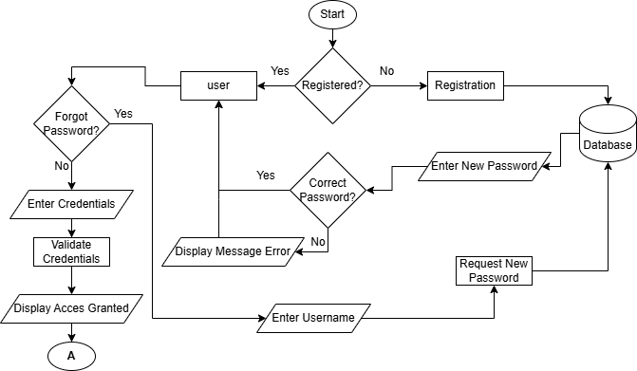

Figure 2 Login and Register

**Payment and Recipe Search**

**Figure 3** depicts the flow from inputting ingredients to receiving recipe suggestions, with decision points based on the user’s subscription plan. If the user exceeds the free usage limit, the system offers the option to upgrade to a premium or pro plan to continue searching for recipes.

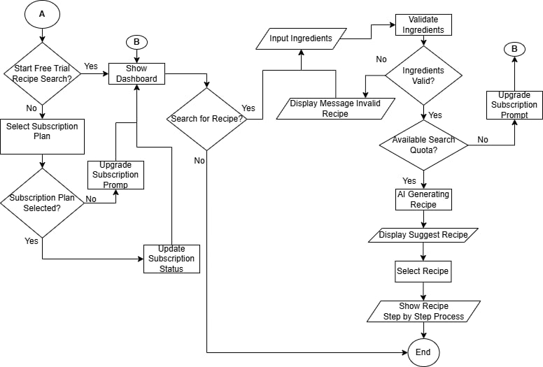

Figure 3 Payment and Recipe Search

**Admin Login**

Figure 4 shows the login process specific to administrators. Upon entering valid credentials, admins gain access to administrative tools such as user management, subscription control, and analytics. Invalid attempts result in error notifications.

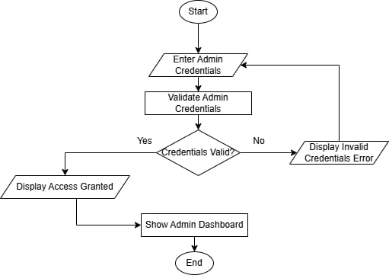

Figure 4 Admin Login Flowchart

**Context Level Diagram**

Figure 5 presents a context-level overview of the KITCHENPAL system. It identifies the external entities—users and admins—that interact with the system and shows the major data inputs and outputs exchanged during operation.

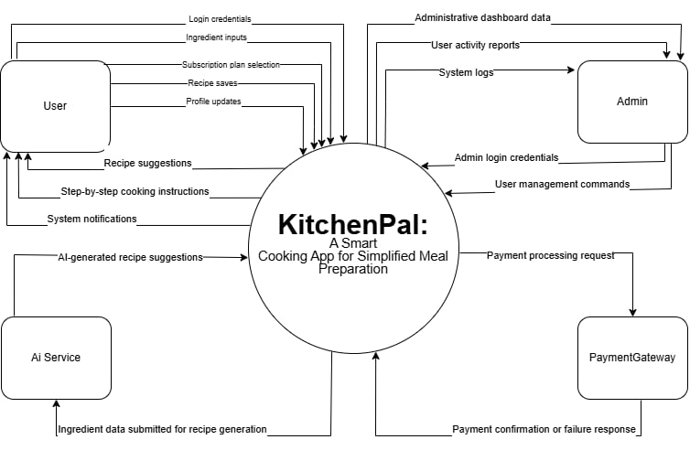

Figure 5 Context Level Diagram

Activity Diagram

The following activity diagrams illustrate the dynamic workflows of various user and admin interactions within the KITCHENPAL mobile application. Each diagram visualizes the sequence of actions taken during specific tasks, such as registration, login, ingredient input, recipe saving, profile editing, subscription management, and administrative functions. These diagrams help model the behavior of the system by showing how control flows from one activity to another, supporting clear understanding of both user experience and system logic.

Registration

Figure 6 details the steps involved when a user registers for the app. It includes entering personal information, validating input, and storing the data in the system’s database. Successful registration leads the user to the login page.

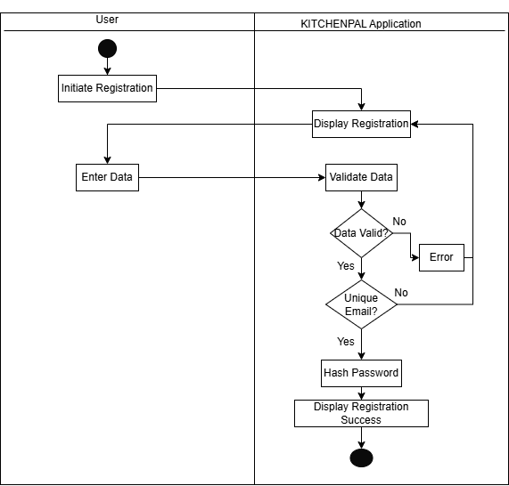

Figure 6 Registration Activity Diagram

Login

Figure 7 outlines the login workflow. Users input their credentials, which are authenticated against stored data. Depending on the result, the system grants access or provides a failure message prompting retry.

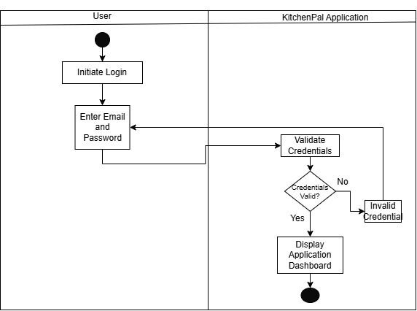

Figure 7 Login Activity Diagram

Input Ingredients and View Recipe Suggestions

Figure 8 demonstrates how users enter available ingredients and receive AI-powered recipe suggestions. It shows the loop of input, processing, and displaying recipes based on matching ingredients.

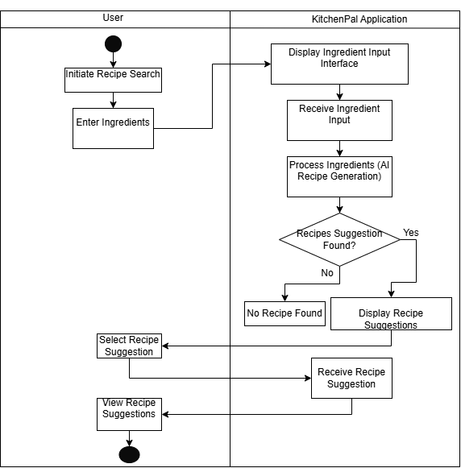

Figure 8 Input Ingredients and View Recipe Suggestions Activity Diagram

Save Favorite Recipe

Figure 9 illustrates the feature allowing users to save recipes they like into the Favorite section. After viewing a recipe, users can select an option to add it to their personal favorites list, stored in their user profile for future access.

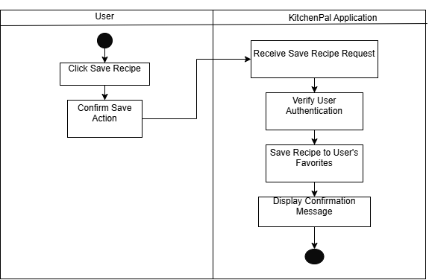

Figure 9 Save Favorite Recipe Activity Diagram

Save Recipe

Figure 10 illustrates the activity flow for saving a recipe in the KITCHENPAL mobile application. After a user creates a new recipe or selects an AI-generated one, they are provided with an option to customize it before saving. The user may rename the recipe, modify its ingredients, and adjust cooking instructions to better match their preferences. Once finalized, the system stores the recipe in the user’s personal collection, enabling future access and editing.



Figure 10 Save Recipe

Edit User Profile

Figure 11 explains the flow for editing user profiles. Users can modify details such as name, email, and preferences. Once changes are saved, the updated information is stored in the database.

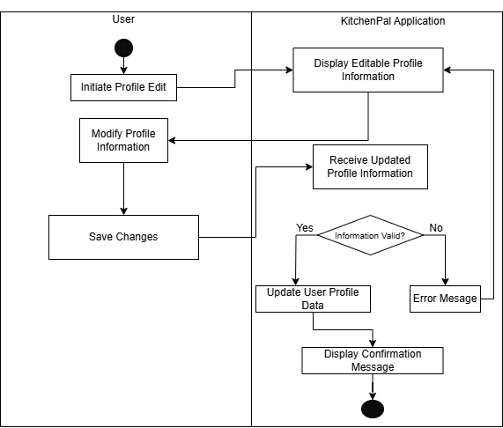

Figure 11 Edit User Profile Activity Diagram

Subscription Plan

Figure 12 displays how users interact with available subscription plans. It includes plan selection, payment confirmation, and plan activation or change. This flow ensures users receive the appropriate access tier.

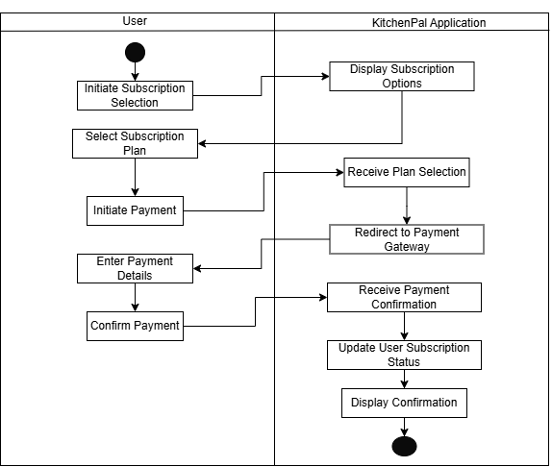

Figure 12 Subscription Plan Activity Diagram

Admin Login

Figure 13 outlines the activity steps for admin access. Similar to user login, it validates credentials but redirects successful logins to the admin dashboard, where additional controls are available.

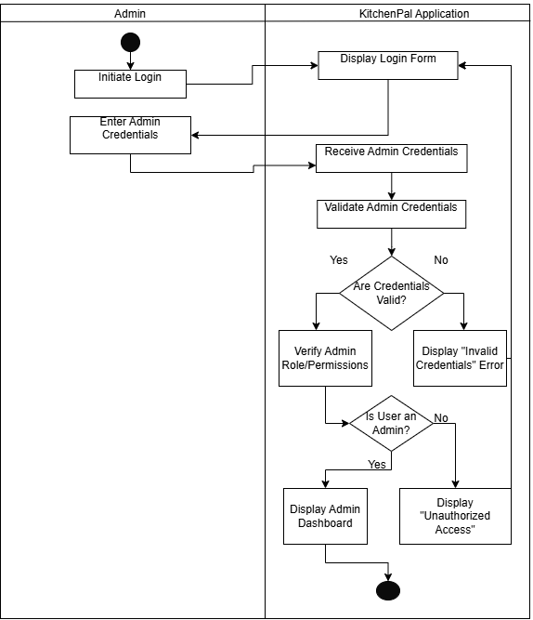

Figure 13 Admin Login Activity Diagram

User Management

Figure 14 illustrates the process by which administrators manage user accounts. It includes selecting a user and executing actions like banning, unbanning, or resetting passwords based on admin authority.

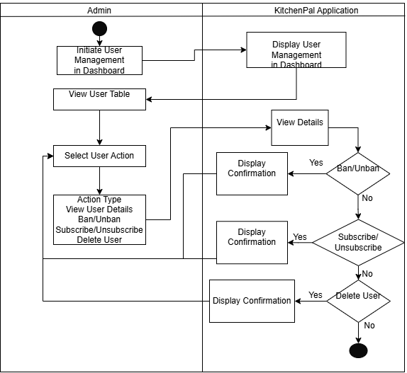

Figure 14 User Management Activity Diagram

Sequence Diagram

The sequence diagrams shown below illustrate the chronological interaction between users and the KITCHENPAL system components. These diagrams are essential for modeling how different objects—such as the user interface, backend services, and database—interact over time to complete specific tasks.

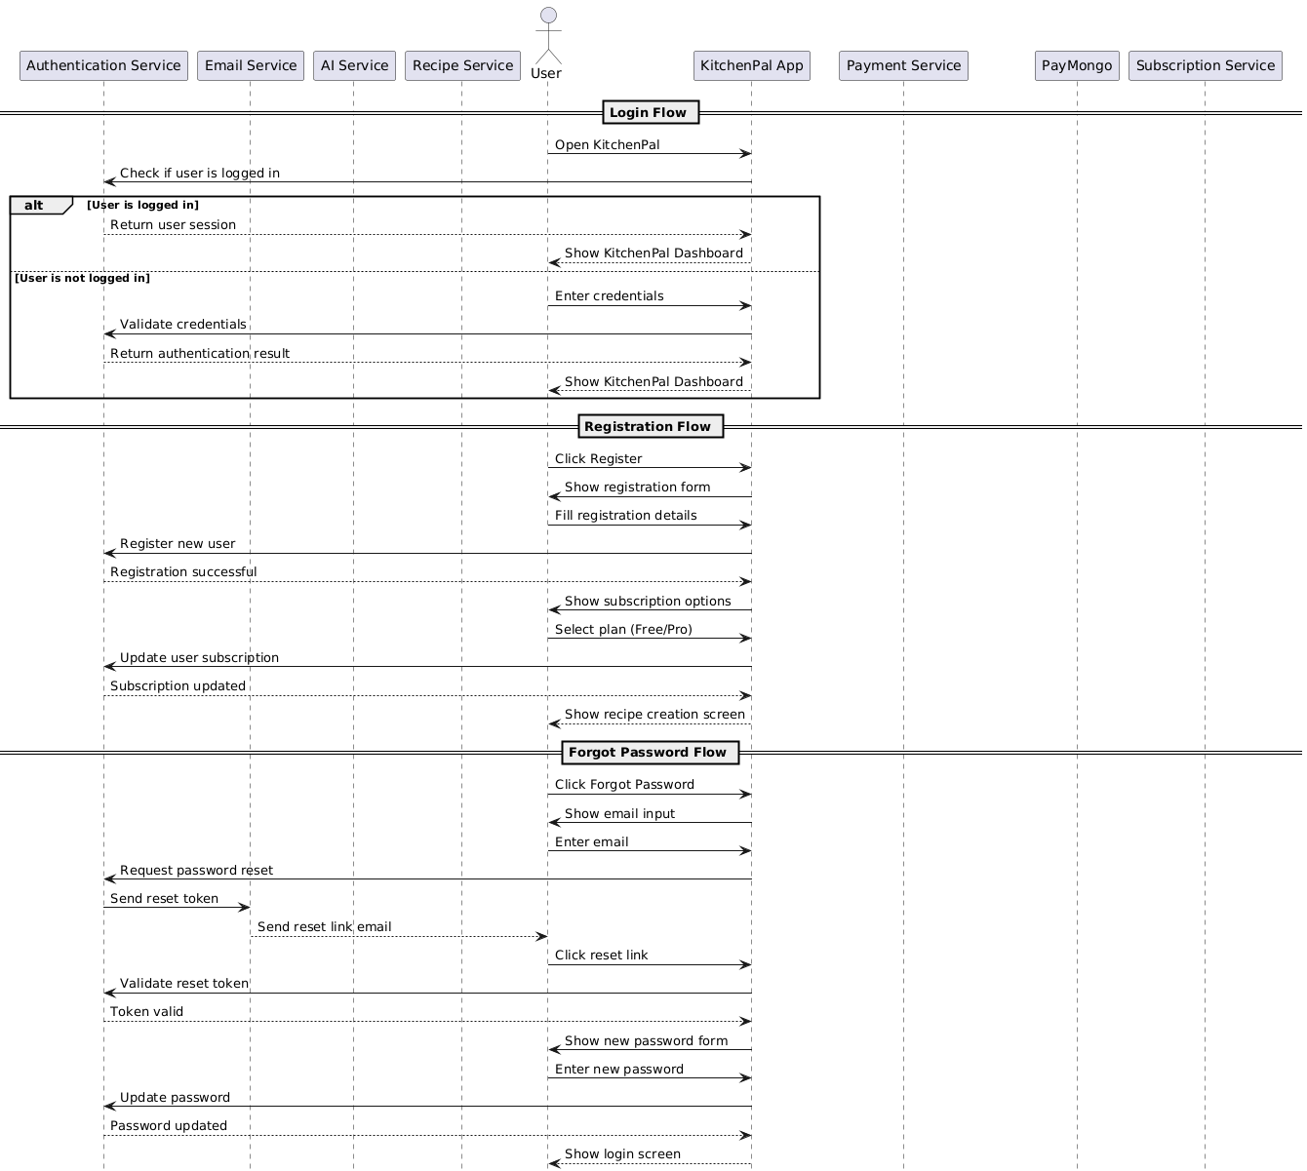

Figure 15 Sequence Diagram Part 1

Figure 15 Part 1 shows a sequence diagram focusing on user login and ingredient input. It demonstrates interactions between the user, app interface, and backend system components during the login phase.



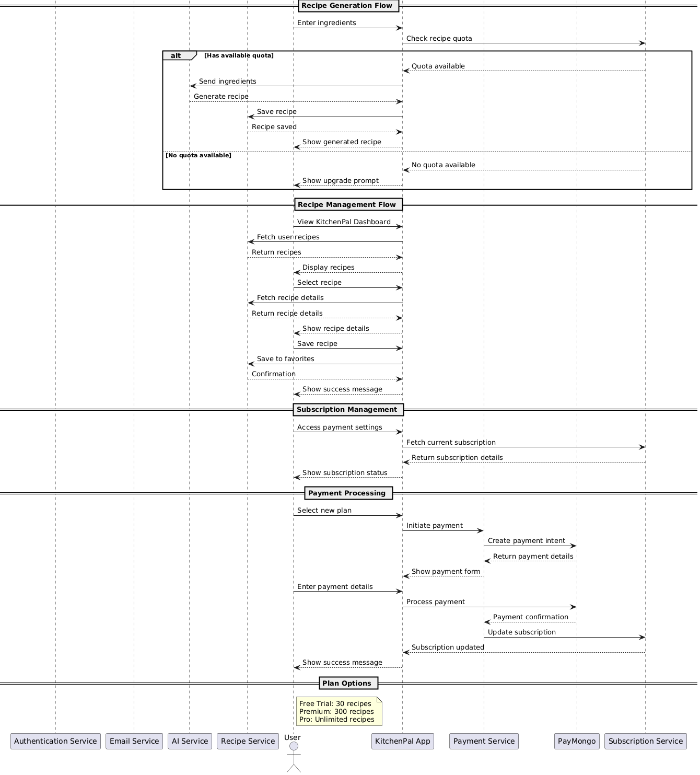

Figure 16 Sequence Diagram Part 2

Figure 16 Part 2 continues from the first sequence and shows how the system generates and displays recipe suggestions. It includes data flow from the ingredient input to AI processing and recipe retrieval**.**

**Entity Relationship Diagram**

Figure 17 presents the structure of the app’s database. It shows the entities such as users, ingredients, recipes, and subscriptions, as well as how these entities are linked through foreign key relationships.



Figure 17 Entity Relationship Diagram

**Use Cases**

Figure 18 illustrates the different use cases within KITCHENPAL, highlighting how both regular users and admins interact with the system. It maps functions like login, recipe generation, and user management to their respective actors.

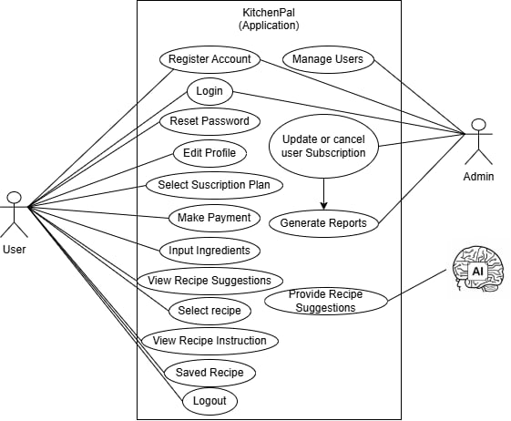

Figure 18 Use Cases

**Project Management**

Project management for the **KITCHENPAL** mobile app focuses on overseeing the development, ensuring that costs and benefits align with the project’s objectives, and providing a roadmap to meet timelines and expectations. This section includes the **Project Cost Estimate** and **Project Cost Benefit Analysis**, which are essential for evaluating the financial and operational aspects of the app's development.

**Project Cost Estimate**

The Project Cost Estimate outlines the financial requirements for the app's development, maintenance, and deployment. These costs are divided into the following categories:

|  |  |  |  |  |
| --- | --- | --- | --- | --- |
| Item | Purpose | Monthly Cost (₱) | Duration | Total Cost (₱) |
| React Native | Frontend framework | ₱0 | — | ₱ |
| Firebase | Backend (auth, database, hosting) – Free Tier | ₱1500(Pay as you Go) | 6 | ₱9000 |
| Figma | UI/UX Design | ₱1000 (Professional Plan) | 6 | ₱6000 |
| GPT-4o | AI Recipe Generation (Optional use) | ₱1,200 (ChatGPT Plus) | 6 | ₱7,200 |
| Cursor | IDE | ₱1,200 (Pro) | 6 | ₱7,200 |
| GitHub | Version Control & Collaboration | ₱250 (Pro) | 6 months | ₱1,500 |
| Domain Name | Custom website domain | ₱800 | 1 year | ₱800 |
| Labor (Dev Team) | Development work | ₱60,000 | — | ₱60,000 |
| Contingency Budget | Unexpected costs (e.g., plugins, assets) | — | — | ₱3,000 |
| Total |  |  |  | ₱94,700 |

Table 16 Project Cost Estimate

3.7.2 Project Cost Benefit Analysis

The Project Cost Benefit Analysis helps determine if the benefits of the KITCHENPAL app are worth the costs. It shows whether the project is financially feasible and sustainable for future development and commercialization.

|  |  |
| --- | --- |
| Aspect | Details |
| Expected Revenue Streams | - Free Plan: 30 searches/month (no charge) - Premium Plan: ₱149/month, 300 searches (target: 100 users) - Pro Plan: ₱399/3 months, unlimited searches (target: 50 users per quarter) |
|  | - Estimated Revenue (Year 1):     - Premium: ₱149 × 100 users × 12 months = ₱178,800     - Pro: ₱399 × 50 users × 4 quarters = ₱79,800 - Total Subscription Revenue: ₱178,800 + ₱79,800 = ₱258,600 |
| Total Estimated Benefits | ₱258,600 |
| Total Estimated Costs | ₱94,700 (refer to Table 3.1) |
| Return on Investment (ROI) | ROI = (Total Benefits − Total Costs) / Total Costs ROI = (₱258,600 − ₱94,700) / ₱94,700 ≈ 1.73 or 173% |
| Break-even Point | Expected within 4 to 6 months after launch, assuming consistent user acquisition |
| Non-Monetary Benefits | - Increased brand visibility - Community engagement - Potential strategic partners |

Table 17 Project Cost Benefit Analysis

**Gantt Chart**

The Gantt chart below serves as a project planning outline for the development of the KITCHENPAL mobile application. It provides a structured timeline based on the Waterfall model, detailing the planned phases of the project including Requirements Gathering, System Design, Implementation, Testing, Deployment, and Maintenance. Each task is organized sequentially to guide the development process, ensuring that activities are completed within their designated timeframes and that project milestones are met efficiently

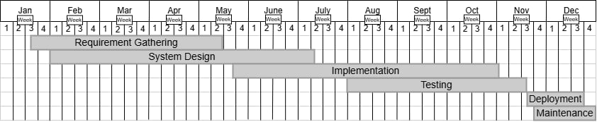

Figure 19 Gantt Chart

**Summary**

This study aimed to develop KITCHENPAL, a smart cooking mobile application designed to simplify meal preparation by generating AI-powered recipe suggestions based on available ingredients. The system was developed using the Waterfall methodology, ensuring a clear and structured progression from requirements gathering to deployment.

Throughout the development process, requirements were collected from home cooks through interviews and surveys, leading to a design that emphasized simplicity, accessibility, and real-time functionality. The app was implemented using React Native for cross-platform compatibility and Firebase for backend and data management. Key features include user account management, ingredient input, AI-driven recipe generation, step-by-step cooking instructions, favorite recipe saving, and subscription-based access.

System evaluation included functional and non-functional testing, confirming that the app performs as expected, is user-friendly, secure, and reliable. With successful deployment on both Android and iOS platforms, the app is ready for real-world use.

**Appendices**

**Project Team Management**

|  |  |  |
| --- | --- | --- |
| **Name** | **Role** | **Responsibilities** |
| Christian Lloyd B. Bringas | Project Leader | Oversees project planning, coordinates team efforts, and manages timelines. |
| Sheala Mae C. Masendo | Lead Developer | Responsible for coding, integration of AI and backend systems. |
| Riezel B. Dedicatoria | UI/UX & Documentation Lead | Designs app interfaces using Figma, and prepares technical documentation. |

Table 18 Project Team Management

**Project Prototype**

The following section presents a prototype of the research project, offering a preliminary visualization of the system's structure and key features. This prototype is designed to demonstrate the basic flow and functionality, serving as a reference for further development. While not yet fully operational, it outlines the essential components and interface design, providing a foundation for feedback and iterative improvement. The researcher developed this prototype to guide future implementation and ensure alignment with the project objectives.

**Login and Register**

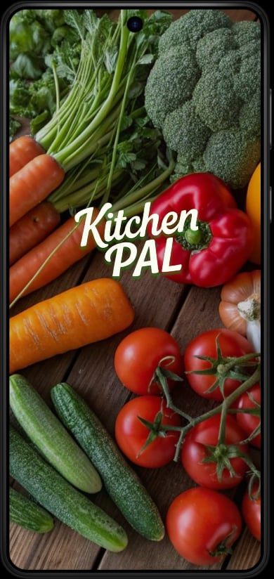

Figure 20 Login and Register

**Searching Recipe**

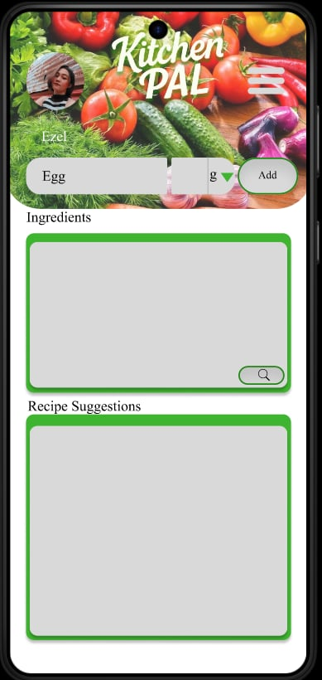 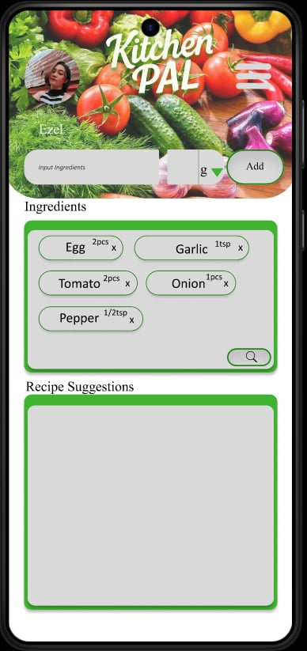

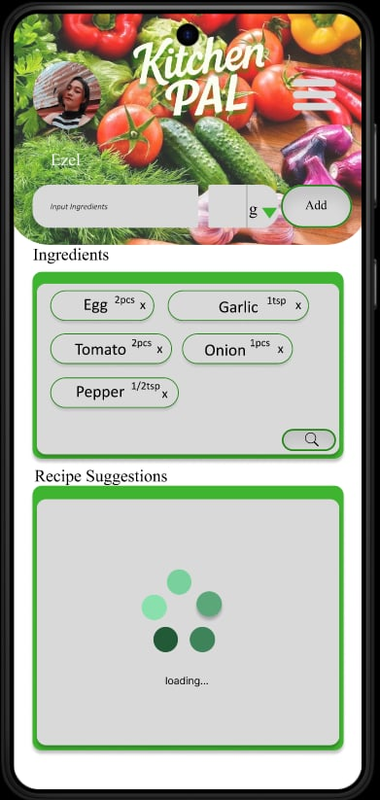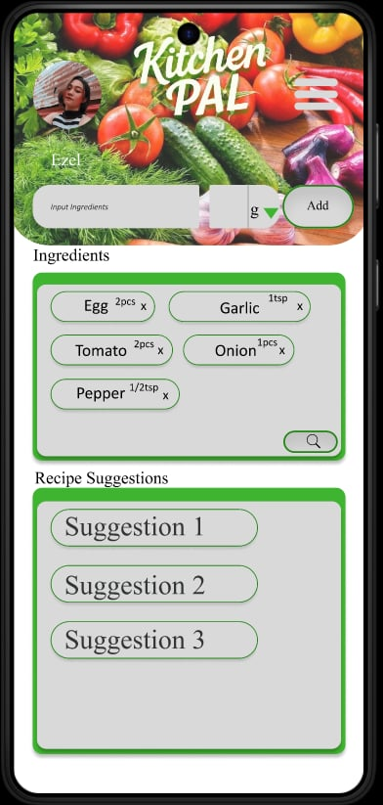

Figure 21 Searching Recipe

**Profile Editing**

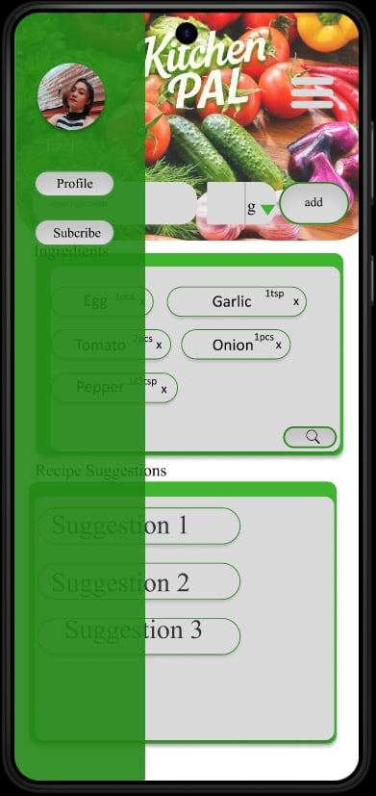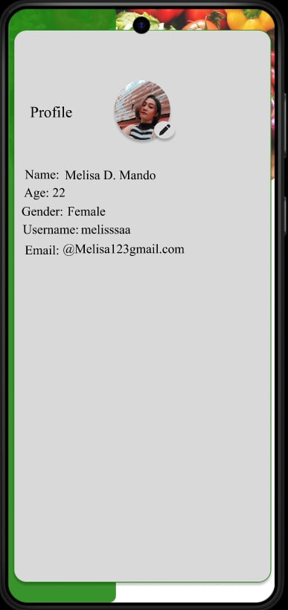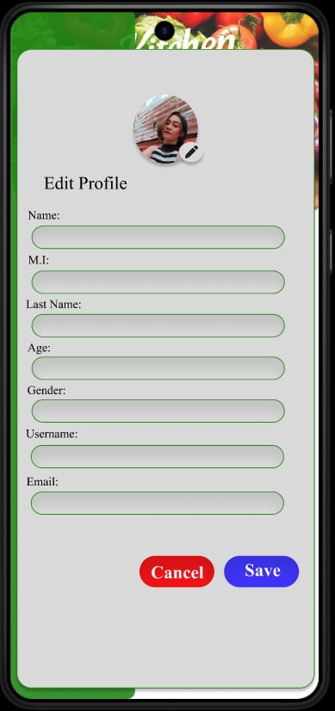

Figure 22 Profile Editing

**Menu icon**

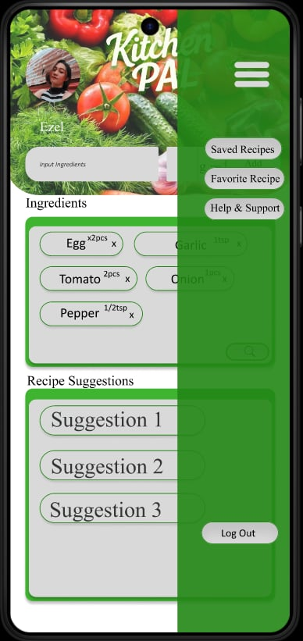 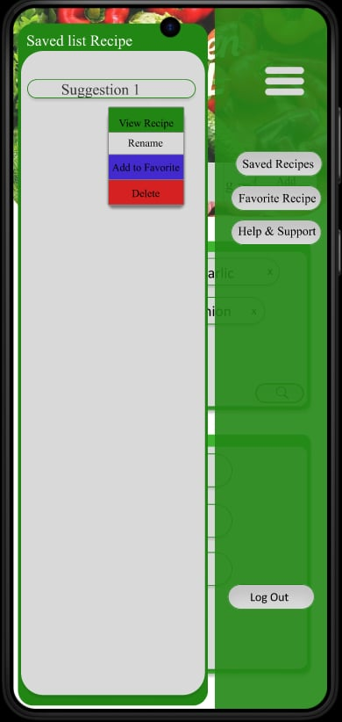 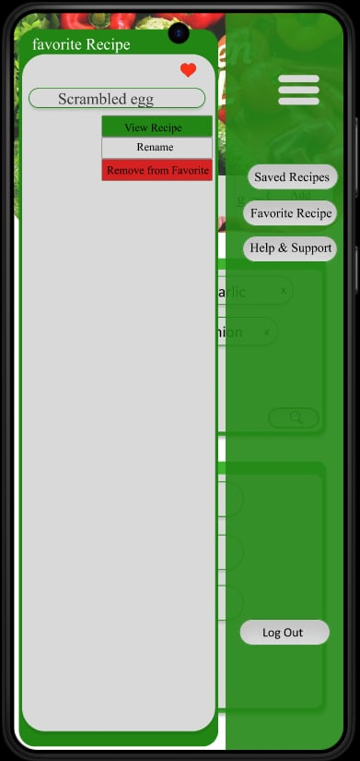

Figure 23 Menu icon

**

Figure 24 Admin Dashboard and User Management

**Evaluation Tool**

**Purpose**

The Evaluation Tool is designed to assess the performance, functionality, usability, and user satisfaction of the KITCHENPAL mobile application after development and during the testing phase. This ensures that the application meets its intended objectives and provides value to its target users—home cooks and individuals who have limited cooking experience.

**Evaluation Framework**

The evaluation will be conducted using both quantitative and qualitative approaches. These include structured surveys using a Likert scale, functional testing checklists, and direct user feedback during beta testing. The combination of these tools will help provide a comprehensive assessment of the system's effectiveness.

Evaluation Criteria and Methods

|  |  |  |  |
| --- | --- | --- | --- |
| Evaluation Aspect | Description | Tool/Method | Success Indicator |
| Functionality | Are core features working as expected? | Functional Testing Checklist | ≥ 90% of features pass testing |
| Usability | Is the interface user-friendly and easy to navigate? | Usability Survey (Likert Scale) | Average score ≥ 4.0 out of 5 |
| Performance | How fast and responsive is the app? | Manual testing / Response timers | Loads in < 3 seconds on average |
| AI Accuracy | Are recipe suggestions relevant to the entered ingredients? | User Feedback Survey | ≥ 80% of users find suggestions accurate |
| User Satisfaction | Do users find the app helpful and enjoyable to use? | Post-Usage Questionnaire | ≥ 85% satisfied users |

Table 19 Evaluation Criteria and Methods

1. Usability and Satisfaction Survey (Likert Scale)

Instructions: Please rate the following statements from 1 (Strongly Disagree) to 5 (Strongly Agree):

|  |  |  |
| --- | --- | --- |
| No. | Statement | Rating (1–5) |
| 1 | The app is easy to use and navigate. |  |
| 2 | I understood how to input ingredients and generate recipes. |  |
| 3 | The recipe suggestions matched my available ingredients. |  |
| 4 | I could easily save and find my favorite recipes. |  |
| 5 | The app loads quickly and responds smoothly. |  |
| 6 | I would recommend this app to others. |  |

Table 20 Usability and Satisfaction Survey

2. Developer Functional Testing Checklist

|  |  |  |
| --- | --- | --- |
| Feature | Status (To be tested) | Notes |
| User Registration/Login | ☐ |  |
| Ingredient Input | ☐ |  |
| AI Recipe Generation | ☐ |  |
| Save/Modify Recipes | ☐ |  |
| Add to Favorites | ☐ |  |
| Admin Dashboard Functions | ☐ |  |
| Subscription Payment Handling | ☐ |  |

Table 21 Developer Functional Testing Checklist

**Evaluation Timing**

The evaluation will be conducted during the beta testing phase of the application. Test users will be asked to use the app and complete the evaluation survey. Developers will concurrently use the checklist to verify technical performance and feature completeness.

**Users Guide**

### **1. Getting Started**

1.1 Creating an Account

To use KITCHENPAL, you first need to create an account:

1. Open the app and tap on the **Register** button.
2. Enter your **full name**, **email address**,

username, and **password**.

1. Tap Register button to create your account.
2. You will receive a confirmation email.

Follow the instructions to verify your account.

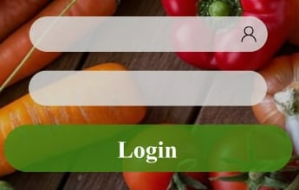1.2 Logging in

Once your account is created, you can log in:

1. Open the app and tap on the **Login** button.
2. Enter your **email address** and **password**.
3. Tap **Login** to access your personal dashboard.

### **2. Adding Ingredients**

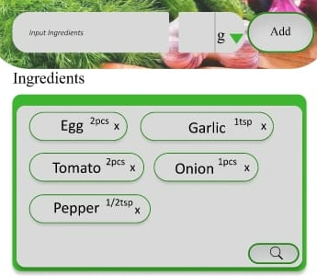Once logged in, you can begin adding ingredients

that you have available in your kitchen:

1. Type the name and quantity of an ingredient

in the text box (e.g., "tomato," "chicken").

1. Tap **Add Ingredient** to store it in your list.

**3. Searching for Recipes**

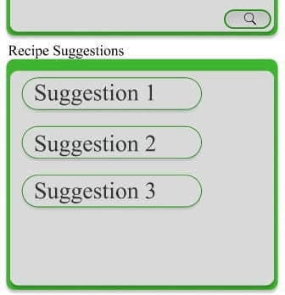With your ingredients added, you can search for recipes:

1. On the **Recipe Search** screen, tap the **Search**

**Recipes** button.

1. The system will generate a list of recipes based

on the ingredients you entered.

1. Tap on any recipe to view detailed information,

including ingredients, cooking instructions, and

preparation steps.

### **4. Saving Recipes**

You can save your favorite recipes for later use:

1. 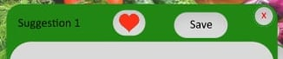After viewing a recipe, tap on the **Save or Save to**

**Favorites** button.

1. The recipe will be added to your personalized

favorites list for easy access.

### **5. Viewing Cooking Instructions**

To view detailed step-by-step instructions for any recipe:

1. 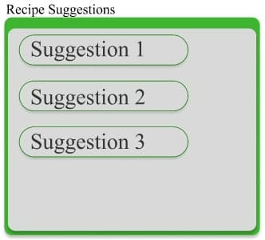Tap on the desired recipe from your search

results or favorites.

1. Scroll down to the **Recipe Steps** section.
2. Follow the instructions as you cook.

### **6. Editing Your Profile**

You can update your account details at any time:

1. From the main dashboard, tap on **Profile**.
2. Select **Edit Profile** to update your **name**,

**email**, and **preferences**.

1. Tap **Save** to confirm changes.

### **7. Subscription Plans**

KITCHENPAL offers three subscription tiers:

1. 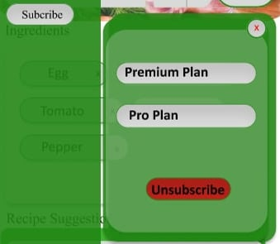**Free**: Allows up to 30 recipe searches per month.
2. **Premium**: Allows up to 300 recipe searches per month.
3. **Pro**: Unlimited recipe searches.

To change your subscription plan:

1. Tap on **Subscription Plan** from the menu.
2. Choose a plan that best suits your needs.
3. 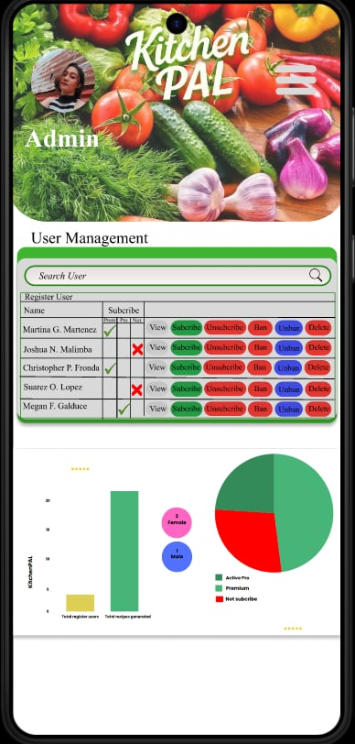Follow the prompts to confirm and activate your selected plan.

### **8. Admin Features (For Admin Users Only)**

If you have administrative privileges:

1. **Login** using your admin credentials.
2. Access the **Admin Dashboard**, where you

can manage user accounts, review usage statistics,

and manage subscriptions.

1. You can **ban** or **unban** users, reset passwords,

and monitor activity for reports.

**9. Help and Support**

If you encounter issues with the app or have questions:

* Visit the **Help Center** in the menu.
* Contact our support team via the **Contact Us** section

for additional assistance.

**Sample Output**

Figure 25 Sample Output

**CURRICULUM VITAE**

**PERSONAL INFORMATION**

**Name:**  
Christian Lloyd B. Bringas  
**Address:**  
Brgy. Carmen, Tacurong City, Sultan Kudarat  
**Contact Number:**  
09811230934  
**Email Address:**  
christianlloydbringas26@gmail.com  
**Date of Birth:**  
10/26/1997  
**Civil Status:**  
Single  
**Citizenship:**  
Filipino  
**Gender:**  
Male

**CAREER OBJECTIVE**

To apply my skills and knowledge in technology and software development to contribute to innovative projects, gain practical experience, and grow as a competent IT professional.

**EDUCATIONAL BACKGROUND**

**Tertiary Education**  
Southern Mindanao Institute Of Technology Inc.  
Bachelor of Science in Information Technology  
2025-2026

**Secondary Education**  
Panay National High School  
2013-2014

**Elementary Education**  
San Vicente Elementary School  
2009-2010

**TECHNICAL SKILLS**

* Web Development (HTML, CSS, JavaScript, PHP)
* Database Management (MySQL, PhpMyAdmin)
* UI/UX Design (Tailwind CSS, Wireframing)
* MS Word, Excel, PowerPoint

**PROJECTS**

**Capstone Project:**

**Title:** **KITCHENPAL:** A Smart Cooking App for Simplified Meal Preparation

**Role:** Project Leader

**Description:** KitchenPal is a mobile app that helps users find recipes based on the ingredients they already have. It is made for both people who know how to cook and those who don’t. The app gives step-by-step instructions and lets users save their favorite recipes.

**SEMINARS & TRAININGS ATTENDED**

* Digital Career Expo – Tacurong City August 20, 2024
* National Certificate II in Computer System Servicing

**CHARACTER REFERENCES**

Grace N. Aprosta, MIT  
Position: Instructor/Adviser   
School: Southern Mindanao Institute of Technology Inc.  
Contact: aprostagrace@gmail.com

**CURRICULUM VITAE**

**PERSONAL INFORMATION**

**Name:**  
Riezel B. Dedicatoria  
**Address:**  
Brgy. Brgy. Upper Katungal, Tacurong City, Sultan Kudarat  
**Contact Number:**  
09066009537  
**Email Address:**  
dedicatoriabriezel@gmail.com  
**Date of Birth:**  
01/04/2003  
**Civil Status:**  
Single  
**Citizenship:**  
Filipino  
**Gender:**  
Female

**CAREER OBJECTIVE**

To apply my knowledge and skills in software development, mobile application design, and user-centered technology solutions in a dynamic and growth-oriented environment. I aim to contribute to innovative projects, enhance user experiences through technology, and continuously develop as an IT professional with a strong focus on practical problem-solving and modern development tools.

**EDUCATIONAL BACKGROUND**

**Tertiary Education**  
Southern Mindanao Institute of Technology Inc.  
Bachelor of Science in Information Technology  
2025-2026

**Senior High School Education**

Notre Dame-Siena College of Tacurong, Inc.

2021-2022

**Secondary Education**  
Salaman Institute  
2018-2019

**Elementary Education**  
Pakil Elementary School  
2013-2014

**TECHNICAL SKILLS**

* Web Development (HTML, CSS, JavaScript, PHP)
* Database Management (MySQL, PhpMyAdmin)
* UI/UX Design (Tailwind CSS, Wireframing)
* MS Word, Excel, PowerPoint

**PROJECTS**

**Capstone Project:**

**Title:** **KITCHENPAL:** A Smart Cooking App for Simplified Meal Preparation

**Role:** UI/UX & Documentation Lead

**Description:** KitchenPal is a mobile app that helps users find recipes based on the ingredients they already have. It is made for both people who know how to cook and those who don’t. The app gives step-by-step instructions and lets users save their favorite recipes.

**SEMINARS & TRAININGS ATTENDED**

* Digital Career Expo – Tacurong City August 20, 2024
* National Certificate II in Computer System Servicing

**CHARACTER REFERENCES**

Grace N. Aprosta, MIT  
Position: Instructor/Adviser   
School: Southern Mindanao Institute Of Technology Inc.  
Contact: aprostagrace@gmail.com

**CURRICULUM VITAE**

**PERSONAL INFORMATION**

**Name:**  
Sheala Mae C. Masendo  
**Address:**New Egaña D’lotilla, Isulan, Sultan Kudarat  
**Contact Number:**  
09308153862  
**Email Address:**  
masendoshealamae@gmail.com  
**Date of Birth:**  
10/23/2001  
**Civil Status:**  
Single  
**Citizenship:**  
Filipino  
**Gender:**  
Female

**CAREER OBJECTIVE**

To obtain a challenging position where I can effectively contribute my skills in technology and innovation, while continuously learning and growing. I aim to be part of a forward-thinking team that values creativity, collaboration, and making a positive impact through practical solutions.

**EDUCATIONAL BACKGROUND**

**Tertiary Education**  
Southern Mindanao Institute Of Technology Inc.  
Bachelor of Science in Information Technology  
2025-2026

**Secondary Education**  
Laguilayan National High School  
2018-2019

**Elementary Education**  
New Egaña Elementary School  
2014-2015

**TECHNICAL SKILLS**

* Web Development (HTML, CSS, JavaScript, PHP)
* Database Management (MySQL, PhpMyAdmin)
* UI/UX Design (Tailwind CSS, Wireframing)
* MS Word, Excel, PowerPoint

**PROJECTS**

**Capstone Project:**

**Title:** **KITCHENPAL:** A Smart Cooking App for Simplified Meal Preparation

**Role:** Project Leader

**Description:** KitchenPal is a mobile app that helps users find recipes based on the ingredients they already have. It is made for both people who know how to cook and those who don’t. The app gives step-by-step instructions and lets users save their favorite recipes.

**SEMINARS & TRAININGS ATTENDED**

* Digital Career Expo – Tacurong City August 20, 2024
* National Certificate II in Computer System Servicing

**CHARACTER REFERENCES**

Grace N. Aprosta, MIT  
Position: Instructor/Adviser   
School: Southern Mindanao Institute Of Technology Inc.  
Contact: aprostagrace@gmail.com